Hooks
- mmcv/runner/hooks
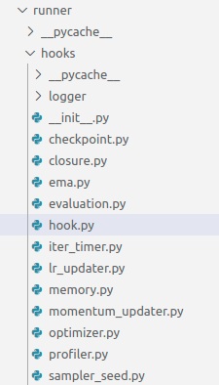

- Hook类定义
HOOKS = Registry('hook')

class Hook:
stages = ('before_run', 'before_train_epoch', 'before_train_iter',
'after_train_iter', 'after_train_epoch', 'before_val_epoch',
'before_val_iter', 'after_val_iter', 'after_val_epoch',
'after_run')

def before_run(self, runner):
pass

def after_run(self, runner):
pass

def before_epoch(self, runner):
pass

def after_epoch(self, runner):
pass

def before_iter(self, runner):
pass

def after_iter(self, runner):
pass

def before_train_epoch(self, runner):
self.before_epoch(runner)

def before_val_epoch(self, runner):
self.before_epoch(runner)

def after_train_epoch(self, runner):
self.after_epoch(runner)

def after_val_epoch(self, runner):
self.after_epoch(runner)

def before_train_iter(self, runner):
self.before_iter(runner)

def before_val_iter(self, runner):
self.before_iter(runner)

def after_train_iter(self, runner):
self.after_iter(runner)

def after_val_iter(self, runner):
self.after_iter(runner)

def every_n_epochs(self, runner, n):
return (runner.epoch + 1) % n == 0 if n > 0 else False

def every_n_inner_iters(self, runner, n):
return (runner.inner_iter + 1) % n == 0 if n > 0 else False

def every_n_iters(self, runner, n):
return (runner.iter + 1) % n == 0 if n > 0 else False

def end_of_epoch(self, runner):
return runner.inner_iter + 1 == len(runner.data_loader)

def is_last_epoch(self, runner):
return runner.epoch + 1 == runner._max_epochs

def is_last_iter(self, runner):
return runner.iter + 1 == runner._max_iters

def get_triggered_stages(self):
trigger_stages = set()
for stage in Hook.stages:
if is_method_overridden(stage, Hook, self):
trigger_stages.add(stage)

# some methods will be triggered in multi stages
# use this dict to map method to stages.
method_stages_map = {
'before_epoch': ['before_train_epoch', 'before_val_epoch'],
'after_epoch': ['after_train_epoch', 'after_val_epoch'],
'before_iter': ['before_train_iter', 'before_val_iter'],
'after_iter': ['after_train_iter', 'after_val_iter'],
}

for method, map_stages in method_stages_map.items():
if is_method_overridden(method, Hook, self):
trigger_stages.update(map_stages)

return [stage for stage in Hook.stages if stage in trigger_stages]

- Hook注册
通过runner函数注册：
- def register_hook(self, hook, priority='NORMAL'):
- def register_hook_from_cfg(self, hook_cfg):
- Hook通过runner的call_hoook调用
def call_hook(self, fn_name):
- 训练阶段的hook流程

